*Logic Specification Template*

|  |  |  |  |
| --- | --- | --- | --- |
| **Student** | Roberto Cantu Reyes | **Program #** | 6 |

|  |  |
| --- | --- |
| **Class Name** | Main |

|  |  |
| --- | --- |
| **Method Name** | main |

|  |  |
| --- | --- |
| **Parameters** | none |

|  |  |
| --- | --- |
| **Class Name** | SimpSons |

|  |  |
| --- | --- |
| **Method Name** | gamma |

|  |  |
| --- | --- |
| **Parameters** | Double num |

}

|  |  |
| --- | --- |
| **Class Name** | Simpsons |

|  |  |
| --- | --- |
| **Method Name** | tDistribution |

|  |  |
| --- | --- |
| **Parameters** | Double x , int dof |
|  |

|  |  |
| --- | --- |
| **Class Name** | Simpsons |

|  |  |
| --- | --- |
| **Method Name** | simpsonsRule |

|  |  |
| --- | --- |
| **Parameters** | Double x , int dof |

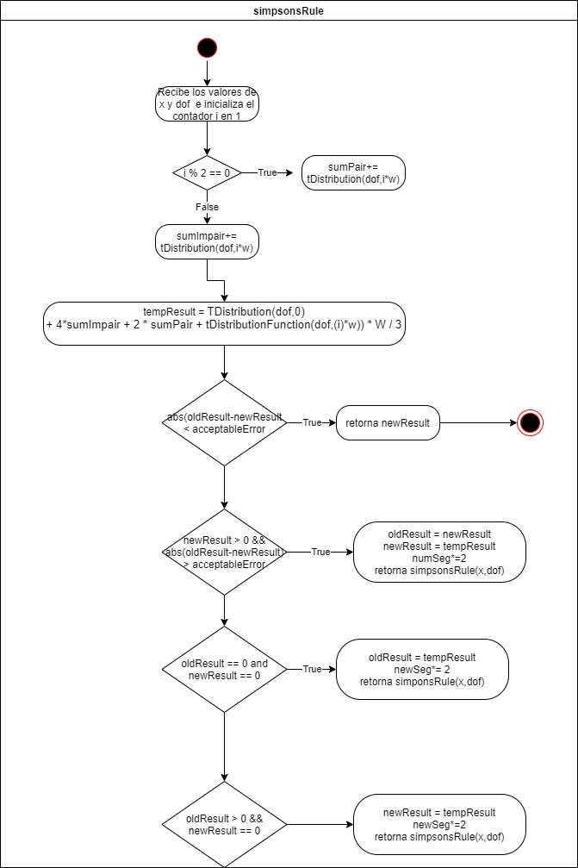

|  |  |
| --- | --- |
| **Class Name** | CalculateX |

|  |  |
| --- | --- |
| **Method Name** | calcX |

|  |  |
| --- | --- |
| **Parameters** | Double x |

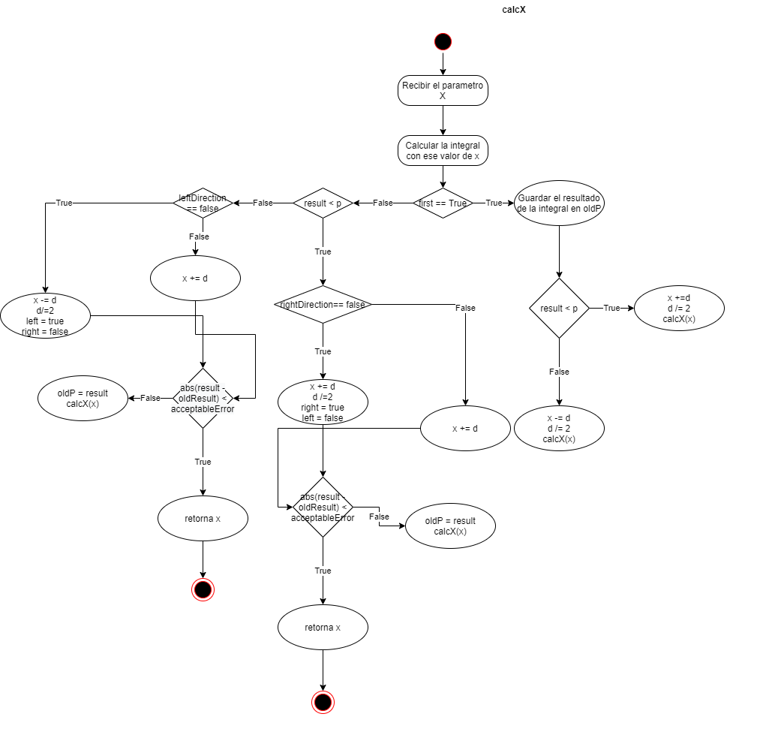

|  |  |
| --- | --- |
| **Class Name** | Significance |

|  |  |
| --- | --- |
| **Method Name** | calcSignificance |

|  |  |
| --- | --- |
| **Parameters** | Double r, int n, double r2 |

|  |  |
| --- | --- |
| **Class Name** | Significance |

|  |  |
| --- | --- |
| **Method Name** | calcX |

|  |  |
| --- | --- |
| **Parameters** | Double r, int n, double r2 |

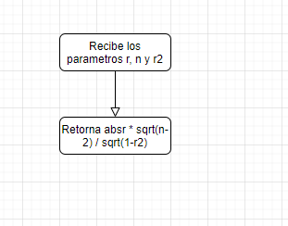

|  |  |
| --- | --- |
| **Class Name** | Significance |

|  |  |
| --- | --- |
| **Method Name** | calcP |

|  |  |
| --- | --- |
| **Parameters** | Double x , int dof |

|  |  |
| --- | --- |
| **Class Name** | Interval |

|  |  |
| --- | --- |
| **Method Name** | sigma |

|  |  |
| --- | --- |
| **Parameters** | Int n, double sum |

|  |  |
| --- | --- |
| **Class Name** | Interval |

|  |  |
| --- | --- |
| **Method Name** | calcRange |

|  |  |
| --- | --- |
| **Parameters** | Double x, int n, double xk, double avgX, double sumYBK, double sumXdif |

|  |  |
| --- | --- |
| **Class Name** | ReadFile |

|  |  |
| --- | --- |
| **Method Name** | printResults |

|  |  |
| --- | --- |
| **Parameters** | Double x, int n, double xk, double avgX, double sumYBK, double sumXdif |

